TOP CLASS LESSON NOTES TERM I

**LEARNING AREA 4 (NUMBERS)**

**TOPICS FOR NUMBERS TO BE COVERED IN TERM ONE.**

* Our numbers
* Addition
* Take away
* Number names
* Size / height
* Sets
* shape

**Learning outcome:**

recognizing, describing and representing numbers and their relationships and solving mathematical problem with competence and confidence.

**Competence:**

Recognizing numbers 1-30

**WEEK 1**

**Activity 1**

**Copy and learn these numbers**

|  |  |  |  |  |  |  |  |  |  |
| --- | --- | --- | --- | --- | --- | --- | --- | --- | --- |
| 1 | 2 | 3 | 4 | 5 | 6 | 7 | 8 | 9 | 10 |
| 11 | 12 | 13 | 14 | 15 | 16 | 17 | 18 | 19 | 20 |
| 21 | 22 | 23 | 24 | 25 | 26 | 27 | 28 | 29 | 30 |

**Activity 2**

**Fill in the missing numbers.**

1 2 4 6 7 9

11 13 15 18 20

**Activity 3**

**Fill in the missing numbers**

1 3 5 7

11 12 15

17 18 21 22

25 28 29 31

32 33 34

**Activity 4**

**Write the next number**

11 12 13 _______ 7 8 _______ 3 4 _______

25 _______ 21 22 _____ 16 17 _____

10 ______

**Activity 4**

**Write the next number**

14 ______ 19 _____ 12______ 24 _____

29 ______ 17 _____

**Activity 5**

**Write the next number**

25 _____ 11 12 ______ 19 _____ 26 27 ______

28 _____ 7 _____

**WEEK 2**

**Activity 1**

**Write number 1-30**

1 2 3 4 5 6 7 8 9 10 11 12 13 14 15 16 17 18

19 20 21 22 23 24 25 26 27 28 29 30

**Activity 2**

**Write the number before**

____3 _____8 _____10 ______ 15 ______20 _____24

**Activity 3**

**Write the number before.**

____14 _____17 ____29 _____30 _____10 ____11

**Activity 4**

**Circle the smallest number.**

1 2 10 11 14 5 9 13

20 29 23 9 15 15 12 4

**Activity 5**

**Circle the smallest number.**

4 10 15 26 19 30 12 4

**WEEK 3**

**Activity 1**

**Count objects and write the numbers**

=

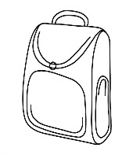  =

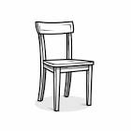=

=

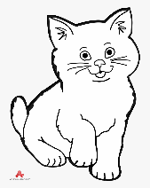 =

=

**Activity 2**

=

=

=

=

=

**Activity 3**

**Draw balls for a given number**

2 =

11 =

14 =

3 =

9 =

**Activity 4**

**Draw balls for a given number**

5 =

12 =

10 =

4 =

7 =

0 =

**Activity 5**

**Circle the correct number for the picture**

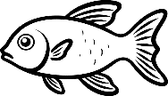 1 4 6

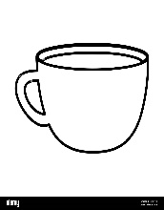     5 7 9

10 6 12

9 20 14

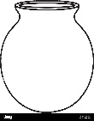  2 5 0

       = 7 13 17

**WEEK 4**

**Number words**

**Activity 1**

**Write words in figures**

one two three seven nine ten

**Activity 2**

**Write the words in figures.**

eleven twelve thirteen

fourteen sixteen five

**Activity 3**

**Circle the correct word for a given number**

14 fourteen four

11 five eleven

10 ten one

15 fifteen seven

2 three two

6 six nine

**Activity 4**

**Write these numbers in words**

20 4 6

10 14 15

**Activity 5**

**Write these numbers in words**

17 5 11

8 19 18

**WEEK 3**

**Activity 1**

**Write these numbers in words**

25 20 24

8 27 10

**Activity 2**

**Match words to numbers.**

Twenty-one 27

Twenty-three 26

Twenty- four 21

Twenty – five 23

Twenty -six 24

Twenty – seven 25

**Activity 3 – 5**

**Circle the correct word.**

27 twenty-seven thirteen

21 two twenty-one

28 twenty-eight eight

22 twelve twenty-two

24 twenty-four one

27 seven twenty-seven

**WEEK 5**

**Learning out come II**

Comparing things according to different attributes

**Competence:**

Showing relationships among things in serial order.

**Activity 1**

**Match a shape to its name**

cone

oval

square

kite

rectangle

triangle

**Learning out come:**

Surveying knowing and distinguishing the attributes of objects.

**Competence:**

Classifying things

**Activity 2**

**Match a shape to a given word.**

line

rectangle

circle

star

zig-zag

triangle

**Activity 3**

**Name these shapes**

**Activity 4**

**Read and draw shapes**

|  |  |  |  |  |  |
| --- | --- | --- | --- | --- | --- |
| Circle | Star | Triangle | Square | Kite | Oval |
|  |  |  |  |  |  |

**Activity 5**

**Fill in the missing letter**

K___te ov____l st____r tri____ngle c___ne squ____re

**WEEK 6**

**Activity 1**

**Addition of objects**

**+ =**

**+ =**

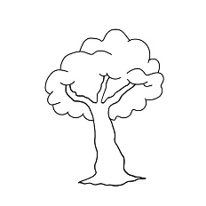 **+** **=**

**+ =**

**+ =**

**Activity 2-5**

**Add the objects**

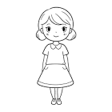**+** **=**

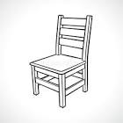 **+**  **=**

**+ =**

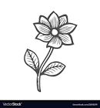 **+** **=**

**+ =**

**WEEK 7**

**Addition of numbers**

**Activity 1**

**Add the numbers.**

2 + 7 = 9 4 + 2 =

11 + 6 = 7 + 3 =

4 + 4 = 5 + 0 =

**Activity 2**

**Add these numbers**

12 + 0 = 3 + 3 = 7 + 1 =

8 + 2 = 5 + 3 = 10 + 0 =

**Activity 3-5**

6 7 4

+ 0 + 2 + 1

1 3 7

+ 8 + 3 + 0

**WEEK 8**

**Activity 1**

**Take away**

**Shade for the number.**

7 =

10 =

0 =

6 =

3 =

4 =

**Activity 2**

3 =

8 =

5 =

1 =

4 =

**Activity 3 – 5**

**Count the shaded objects**

=

=

= =

=

=

**WEEK 9**

**Activity 1**

**Take away these numbers**

9 – 2 = 10 – 5 = 4 – 0 =

7 – 3 = 8 – 2 = 4 – 4 =

**Activity 2**

**Take away these numbers**

11- 4 = 8 – 4 = 10 – 3 =

2 – 2 = 7 – 3 = 7 – 7 =

**Activity 3-5**

10 4 6

- 2 - 2 - 6

2 12 7

- 0 - 4 - 2

**WEEK 9 – 10**

**SETS**

**Count and write**

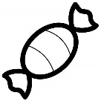 A set of ---------------sweets.

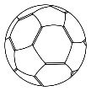  A set of -------------balls.

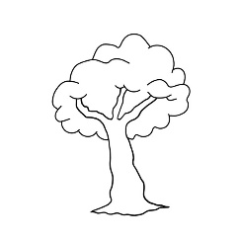A set of -----------tree.

 A set of -----------chairs.

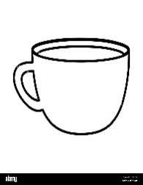 A set of -----------cups.

**WEEK 10**

**Activity 1-5**

**Read and draw**

A set of 6 pens A set of 2 cups

A set of 1 house A set of 3 tables

A set of 4 chairs

**WEEK 11**

**Activity 1-5**

Match short to tall

Circle big objects

Tick small pictures

**Read and draw**

A short tree A big cut

A small tin A tall girl

A big pot A short baby